Bradley University
eGROW Plant Monitoring System
Adam Holler and Clay McKinley, with Dr. Malinowski
Senior Project 2018-2019 for Electrical Engineering

Problem:
With technology increasing day by day, home automation is becoming more available and affordable. One area that is growing substantially is the home monitoring system market. Whether it be for burglaries, thermostats, or lighting, there are solutions that are affordable for the average consumer. We plan to add to an area of the market where only industrial versions are readily available, which is plant/greenhouse monitoring. It will be a low-cost solution for cloud-based plant monitoring.

Requirements:
We will use affordable microcontrollers (such as TI Sensor Tags) to mount at each plant/pot. It will record ambient temperature, board temperature, humidity, sunlight, moisture levels, pressure and also possibly an alert for if the plant tipped over using an accelerometer. If time permits, we may also add the ability to water the plant with a water bottle mount in case the owner is out of town and needs to do a one-time dousing of the plant. The data will be accessible in different formats to the user and we hope to add alarm notifications as well. We plan to use a long-lasting battery, so it should be a one-time setup and hopefully the user does little maintenance to the boards. We also are planning to have the ability to use it both indoors and outdoors. Figure 1 shows how we propose the network will function.
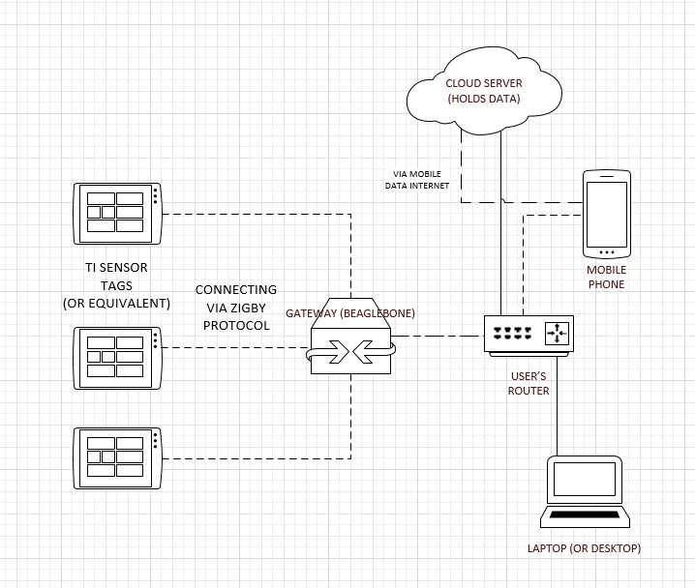
Figure 1. Network Diagram

