RF Charge Pump Design
The objective of this project is to design, optimize and simulate a few RF-DC charge-pump circuits, taking into consideration efficiency and size for real-world implementations. Recently published literature describes the efficacy of such circuits for RF energy harvesting. As seen in Figures 2 and 3, 2-stage and 3-stage charge pumps will be optimized for low received power levels. Charge pumps with more stages will not be considered due to difficulty in fabrication. Since the circuit is inherently nonlinear, standard RF matching techniques can’t be used and the literature will be searched to identify and implement matching techniques appropriate to the nonlinear behavior. This is a very important design deliverable of the project. Design of these circuits will utilize SPICE and ADS. Finally, successful circuit designs will be fabricated by Micro Circuits and components inserted by team members. Experimental results from these circuits will be compared to simulation results.
Some function requirements.
- Energy efficiency based on energy delivered to output capacitor relative to input power to matching circuit measured over a specified time period.
- Load and no load output voltage as function of input power
- Relation of diode parameters to energy efficiency, output voltage.

Matching
Circuit
Charge
Pump
Load

Figure 1: Block Diagram 1

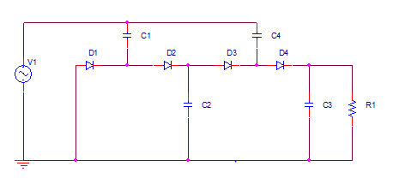

Figure 2: Two-Stage Charge Pump (shown with load)

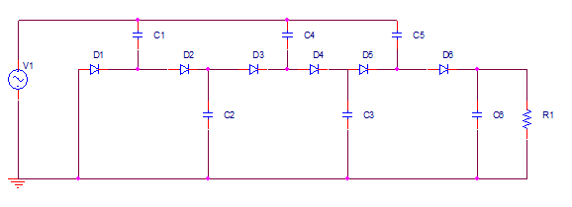
Figure 3: Three-Stage Charge Pump (shown with load)
Description of Block Diagram
Load
For this project we will be using a load that will be able to provide enough voltage and be efficient for the charge pumps. With this in mind, we will most likely use the same approach as the previous seniors who worked on a similar project and choose one with low capacitance and a low resistor. This provides us a load that’s able to charge up proficiently and be more suitable for our purpose.
Charge Pump
The charge pump is to be able to produce charges to fluctuate the voltages by using capacitors. In our project, we will be testing the two-stage and three-stage charge pump as mentioned earlier. Our biggest obstacles for this process are the diodes that will be used. Because it’s nonlinear, the input impedance changes as a function of power. Another thing we must consider is the knee voltage of the diode and whether or not there is enough power for it.
Matching Circuit
For the matching circuit process of the project, we will need to create a design where the input impedance will equal the anticipated value. Here we will be focusing on finding techniques that correspond to the non-linearity properties.

