Design of a Charge Pump for Radio Frequency Energy Harvesting

Senior Capstone Project Proposal (Draft)

By: Safa Baha and Sarah Kuzy

Advisors: Dr. Brian Huggins and Dr. Prasad Shastry

Department of Electrical and Computer Engineering

Bradley University

Peoria, IL 61615

December, 2017
Abstract
The goal of this project is to design, simulate and implement 2 stage and 3 stage RF-DC charge-pump circuits with a focus on impedance matching to the inherently non-linear circuit. Schottky diodes will be used, as these can operate at RF frequencies and have low knee voltages. The charge pumps and matching circuits will be designed and simulated using ORCAD and ADS and the optimized circuits implemented and tested.

- Introduction
This circuit is designed to receive a wireless, RF-signal and convert it to a DC energy output. This will allow the transfer of energy wirelessly. The importance of the charge pump is to take the small amplitude of received RF-signal and produce a much larger voltage output. Therefore, a small amplitude signal can be transmitted and a much higher charge can be used to power a device. The matching circuit allows for a standard 50Ω receiving antenna to be matched to the input impedance of our designed charge pump.
The objective of this project is to design, optimize and simulate a few RF-DC charge-pump circuits, taking into consideration efficiency and size for real-world implementations. Recently published literature describes the efficacy of such circuits for RF energy harvesting [2]. As shown in Figures 3 and 4, 2-stage and 3-stage charge pumps will be optimized for low received power levels. Charge pumps with more stages will not be considered due to difficulty in fabrication, as experienced by the previous project group [1].
Since the circuit is inherently nonlinear, standard RF matching techniques cannot be used and literature will be searched to identify and implement matching techniques appropriate to the nonlinear behavior. This is a very important design deliverable of the project.
Design of these circuits will utilize SPICE and ADS. Finally, successful circuit designs will be fabricated by Micro Circuits and components inserted by team members. Experimental results from these circuits will be compared to simulation results.
The most important functional requirements are as follows:
- Energy efficiency based on energy delivered to output capacitor relative to input energy delivered to the circuit over a given time period
- Steady state load and no load output voltage as function of input power
- Relation of diode parameters to energy efficiency and output voltage
- Relation of charge pump stages to energy efficiency and output voltage

- Block Diagram and Description

RF Signal
Matching Circuit
Charge
Pump
Load
DC

Figure 1: Block Diagram
RF Signal: A sinusoidal radio frequency signal will be used as the input for the complete circuit.
Matching Circuit: The input impedance of the charge pump is a function of the RF signal power. Therefore, it is necessary to measure the input impedance at the expected power level of operation. An impedance matching network to match the charge pump to antenna impedance (50Ω) can then be designed at that power level. As discussed later, the matching network will be implemented on a separate board.
Charge Pump: Two-stage and three-stage charge pumps using Schottky diode will be designed to operate at 915MHz.
Load: The load will be either a capacitive load or a resistor/capacitor combination.
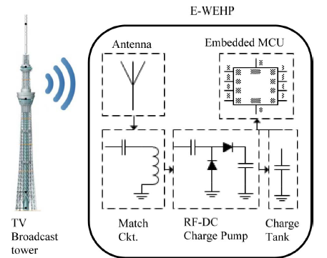
Figure 2: Wireless Energy Harvesting Circuit [2]

Figure 2 is taken from the E-WEHP article [2] about the application of a charge pump for wireless energy harvesting. This is included to demonstrate the application of the charge pump we will design. This application sets our functional requirements of a high frequency, low amplitude sinusoidal input signal. Since wireless energy harvesting is still a technology in development, current literature will be heavily incorporated into this project.

- Design (preliminary)
The current single stage and 2-stage charge pumps are designed as shown in figures 3 and 4. The charge pumps designs are modeled after those used in [2]. We are simulating these charge pumps using high frequency Schottky diodes. For research purposes, we will also be simulating these circuits using much lower frequency 4148 diodes to attempt to prove the following equation that estimates the voltage across the output capacitor [equation 3 from reference 2]. In this equation, the following notation is used: V_{CAP}: Voltage across output capacitor, x: number of stages, V_{f}: input voltage, and V_{d}: the voltage drop across the diode junction. This equation could help us to optimize the number of stages required for the most efficient charge pump for a given input power.
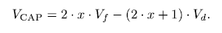
Eqn #1
This equation was not proved in reference 2, nor was there any information on whether this equation was produced empirically or derived from fundamentals.
This equation shows that a smaller V_{d} value is preferable, supporting the use of Schottky diodes.

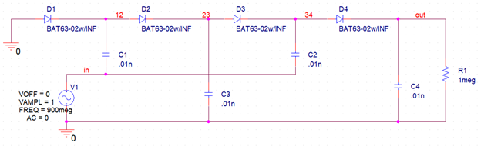
Figure 3: 2-Stage Charge Pump using Schottky Diodes
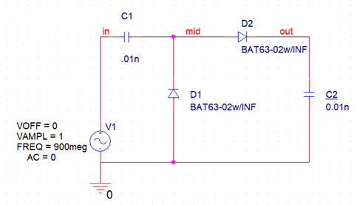
Figure 4: Single Stage Charge Pump using Schottky Diodes

- Specifications
Specifications of charge pump
- Diode: Schottky
- Capacitor Value: 0.01nF
- Frequency: 915MHz
- Output Voltage: 3V-5V Desired
- RF Signal Power: input power will be varied

Matching Technique Used:
Current literature has suggested a matching technique to overcome the inherent nonlinearity of the charge pump circuit. First, the circuit will be fabricated on its own board. Then, after all components are soldered into place, the input impedance of this complete circuit will be measured, using a network analyzer, as a function of input power. A matching circuit will be designed and fabricated separately to match the antenna to the charge pump at the given input power. The final circuit will consist of these two boards connected as shown in figure 2.

- Simulations
Simulations Part 1
The following simulations were used to investigate equation 1. The simulations were performed at 1kHz for the low frequency 4148 diodes. A 2-stage charge pump was tested with both Schottky and 4148 diodes with an input signal at 0.5V, 1kHz and a capacitor of 1uF to compare the effect of the knee voltage on the efficiency of the charge pump.
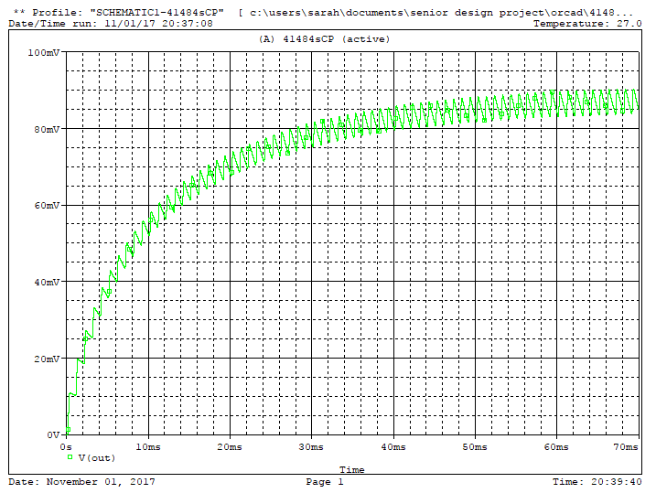
Figure 5: 2-Stage Charge Pump with 4148 Diode Simulated at 0.5V

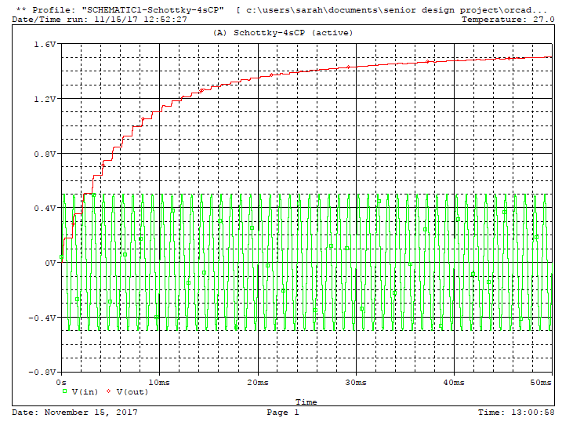
Figure 6: 2-Stage Charge Pump using Schottky Diodes Simulated at 0.5V

From these simulations, it can be seen that the charge pump design using 4148 diodes did not charge above the input voltage of 0.5V. The Schottky diodes produced a steady-state output voltage of almost 1.6V. This demonstrates how important the low turn on value of the Schottky diodes are for the RF applications.
Simulations Part 2
The following simulations were performed at the simulation frequency of 915MHz to compare the efficiency of single versus 2-stage charge pumps. Simulations were performed using 0.01nF capacitors.
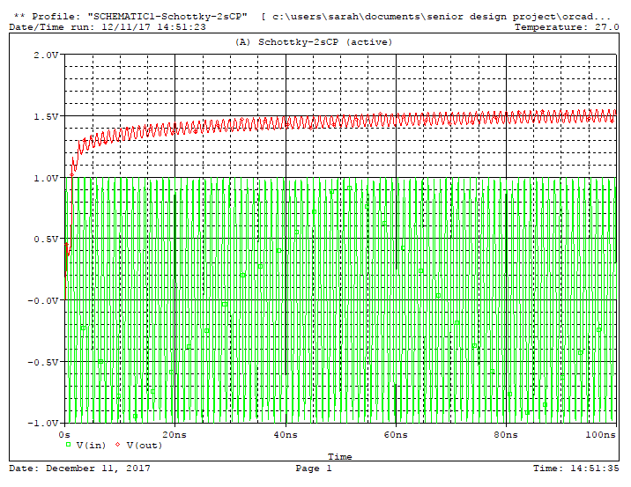
Figure 7: Single Stage Charge Pump using Schottky Diodes Simulated at 1.0V

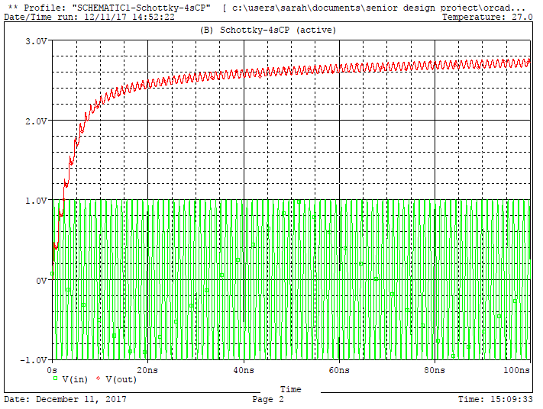
Figure 8: 2-Stage Charge Pump using Schottky Diodes Simulated at 1.0V

- Parts (to be ordered)
- Parts to be ordered before winter break:
  - Schottky Diodes
  - Capacitors
- Circuit Boards [constructed early spring semester]
- Connectors [available in RF laboratory]

- Fabrication and tests/measurements

The charge pumps will be designed on microstrip boards. The software tool ADS will be used for design and simulation. The circuit board will be manufactured at MicroCircuit. The diodes, capacitors, and connectors will be soldered on to the circuit board. As mentioned earlier, the matching circuit will be constructed separately from the charge pump circuit board. The circuit will be tested in the RF laboratory.

- Tasks and schedule (tentative)
Fall Semester:
- Order parts before winter break
Spring Semester:
- Week 1: Design 2 and 3 stage charge pumps
  - 2 boards each for design
    - One with on board capacitive load
    - One with connected capacitive load
- Week 3: Ship designs for construction
  - Work on old boards until constructed boards arrive
  - Practice impedance matching techniques
- Week 5: Soldering components onto boards
  - Measure impedance input of fabricated circuits to design matching networks (completed by Spring Break)
- Week 8: Ship designs for impedance matching networks
  - Work on final reports during waiting period
- Week 10: Connect matching network
  - Begin final measurements
  - Compile final report
This timeline allows for an extra month of time to account for possible delays in the fabrications of the circuits.

- Concluding remarks
This project will design and optimize RF-DC charge pumps with the objective of receiving low-amplitude sinusoidal signals by an antenna to convert to a much higher amplitude DC output. This will be done with the assistance of current literature on the function and design of charge pumps. Also, the required number of stages that optimizes the efficiency of the wireless energy harvesting circuit will be tested and determined. Final results should include a complete circuit that can receive a sinusoidal RF signal and convert it to a higher voltage DC output.

- References
The following documents have been used in our research to further our understanding of the current literature on charge pumps and their behavior.
- Design of Charge Pump for Wireless Energy Harvesting at 915 MHz by McKean and Stoyanov (Project work from previous year)
- E-WEHP: A Batteryless Embedded Sensor-Platform Wirelessly Powered From Ambient Digital-TV Signals by Vyas, Cook, Kawahara, and Tentzeris
- A Wireless Sensing Platform Utilizing Ambient RF Energy by Parks, Sample, Zhao, and Smith
- Design Criteria for the RF Section of UHF and Microwave Passive RFID Transponders by Vita and Iannaccone
- Optimization of UHF Voltage Multiplier Circuit for RFID Application by Bergeret, Pannier, and Gaubert
- Modeling and Design of CMOS UHF Voltage Multiplier for RRFID in an EEPROM Compatible Process by Bergeret, Gaubert, Pannier, Gaultier

