Miniature Urban Electric Vehicle (MUEV)
Phase III

Functional Requirements List and Performance Specifications

10/24/12

Students:
Kevin Jaris
Nate Golick

Advisors:
Steven Gutschlag
Dr. Winfred Anakwa

I. Introduction
This project is entering its third phase for the 2012 - 2013 school year. We will be
focusing on implementing a regenerative braking subsystem to increase the vehicle’s
range and energy efficiency. Most of our research will be on regenerative braking but
first we will have to look at the past projects. We will need to understand what the
previous groups have accomplished, and what they have implemented on the vehicle
already. We may have to model a few subsystems that the past group was unable to
accomplish before beginning the regenerative breaking portion.

II. Goals
1. Use DC motor to slow the flywheel while using power electronics to recover the kinetic energy.
2. Perform multiple simulations to verify our designs.
3. Investigate the possibility of using a variable speed drive to recover energy at lower speeds.
4. Integrate completed design with the Miniature Electric Urban Vehicle (MEUV).

III. System Block Diagram

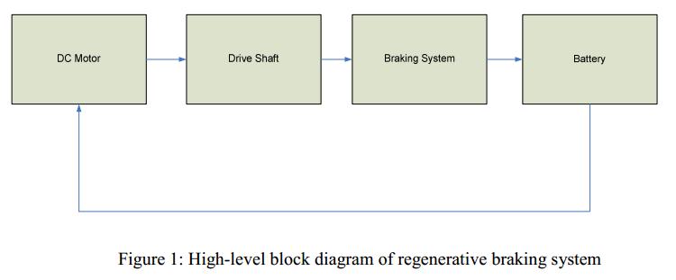 The D&D Separately Excited 24-48 volt DC Motor in Figure 1 spins the drive shaft. The drive shaft will consist of two fly wheels. The braking system will take advantage of the fly wheels kinetic energy to recharge the battery.

IV. Functional Requirement
Braking Subsystem
- Brake pedal will use regen brake up to 75% displacement.
- Brake pedal will use hydraulic brake over 75% displacement.
- Power electronics will recapture the most kinetic energy possible.
- Capacitor bank must store all charge from power electronics.
- Flywheels will capture 15% of cars total kinetic energy at top speed.
- After testing subsystem it will be installed on the MUEV.

References:
Dieter, Kyle, Spencer Leeds, and Nate Mills. Micro Electric Urban Vehicle & Test Platform. Bradley University ECE. Senior Project. May 2010.
Kuhn, Brian, Matthew Leuschke, and Steven Komperda. Micro Urban Electric Vehicle Phase II – Modeling. Bradley University ECE. Senior Project. May 2009.

