Wireless Data Acquisition System (WiDAS)
Senior Project Final Report

By: Justin Peters
Advisor: Professor Steven Gutschlag
May 9, 2010

Abstract:

This WiDAS is intended to be implemented on Bradley University's SAE Formula Car, a full life-cycle design project undertaken by mechanical engineering students at Bradley University every year. The WiDAS gathers information from an assortment of sensors throughout the racecar, including velocity, engine speed, acceleration, coolant temperature, oil pressure, and battery voltage. Once this information has been processed by a microcontroller it is sent real-time to an LCD touch-screen in the vehicle, and also to an off-track laptop via wireless transmitter. The off-track laptop archives the data, and simultaneously provides the user of the off-track laptop with gauges to monitor specific race car parameters.

Table of Contents:

Abstract …………………………………………………………………................................................…………………….….…… 1

Introduction ..............…………………………………………………………………………………………………………………..………. 3

System High-Level Block Diagram ..………………………………………………………………………………………................. 4

System Functions ……………………………………………………………………………………………………………...................... 5

Data Acquisition ……………………….……………………………………………………….......................…….…………. 5

Data Transmission ……………………….…………………………………………………………......................…….……. 8

Wireless Communication .....................…………..………………………………………………………………………. 10

Data Destination ……………………….………......................……………………………………………………………… 11

Touch-screen Display .……….….……………………………………………….................………………..… 12

Touch-screen Selection …………………………………………………………………………………. 13

WinWedge/Excel Interface……….….……………………………………….................……………………. 14

Patents …..…………………………………….……………………………………………………………..............................…………. 17

Equipment …………………………………….……………………………………………………………..............................…………. 17

Conclusion ……………………………….………………………………………….……………………………………................…………. 18

Sources …………………………………….……………………………………………....................................…………………………. 18

Appendices

Appendix A – Amulet Touch-screen µHTML.................................…………………............………………. 19

Appendix B – Wireless Board C Code ………………………………………………………………………………………. 21

Appendix C – Microcontroller C Code ………………………………………………….…………….………………….. 27

INTRODUCTION:
Modern racing has become an extremely competitive sport. While theoretical design is the backbone for its success on the race track, the inability to perform accurate field testing can severely limit a team’s ability to maximize the overall performance of a race car. Better handling and acceleration, as well as other performance specifications, can be obtained by tuning a racecar to non-ideal environments. The ability to fine-tune a race car is an absolute necessity if a racing team is to be highly competitive. Therefore, the analysis of precisely logged data has become critical in the design process of race cars.

Intended to be implemented on Bradley University's SAE Formula Car, the WiDAS gathers information from an assortment of sensors throughout the vehicle, obtaining data on velocity, engine speed, acceleration, coolant temperature, oil pressure, and battery voltage. Once this information has been processed by a microcontroller it is sent real-time to an LCD touch-screen in the vehicle, and also to an off-track laptop via wireless transmitter. The off-track laptop archives the data through the use of a WinWedge software interface, and simultaneously provides the user with gauges to monitor specific racecar parameters through the use of Excel software.

This project is a continuation of several senior project attempts to implement a WiDAS for the Bradley University SAE Formula Car. Only a few specific parts from legacy designs will be used to implement this system, and several legacy concepts have been augmented to fit current project parameters.

SYSTEM HIGH-LEVEL BLOCK DIAGRAM:
Figure 5-1 is a high-level block diagram of the WiDAS system. It illustrates the various inputs applied to the microcontroller on-board the SAE race car. The microcontroller processes the inputs, both analog and digital in nature, and sends the corresponding numerical values to the Amulet STK-480272C touch screen display and Chipcon CC1100 DK wireless transceiver board through EIA-232 interfaces. The touch-screen displays the data it receives from the microcontroller and also sends user inputs back to the microcontroller to provide a bi-directional communication interface. Mounted on the SAE race car, the touch-screen device is situated near the dashboard on the vehicle for the driver to monitor key operating parameters. The Chipcon wireless board on the race car also receives sensor data from the microcontroller through its EIA -232 interface. Sending data from a first-in first-out (FIFO) buffer with the ability to provide variable data packet lengths, the wireless board on the SAE race car transmits data to its partner board near the off-track laptop. WinWedge software then processes the information from the wireless board connected to the off-track laptop for automated entry into Excel so that it can be formatted.
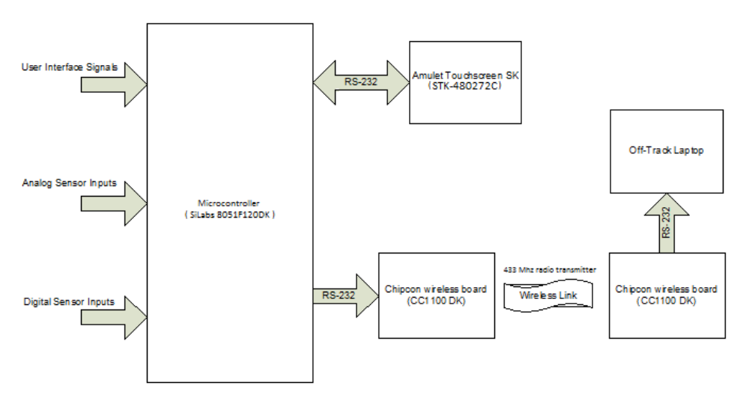
Figure 5-1: System High-level Block Diagram

SYSTEM FUNCTIONS:

This WiDAS provides four major functions: Data Acquisition, Data Transmission, Wireless Communication, and Data Destinations. These functions are explained in the following subsections.

Data Acquisition:

The primary task involved in implementing the WiDAS was programming the microcontroller. The microcontroller interprets the SAE race car's analog and digital sensor data, and sends their corresponding numerical values to both the Amulet touch-screen device in the racecar and the off-track laptop. The microcontroller was programmed in C code so modifications could be implemented quickly and accurately. The code for the microcontroller must be relatively flexible since the mechanical engineering students designing the SAE Formula Car do not yet have the various sensor voltage specifications well defined. (See Appendix C for the microcontroller’s C code.)

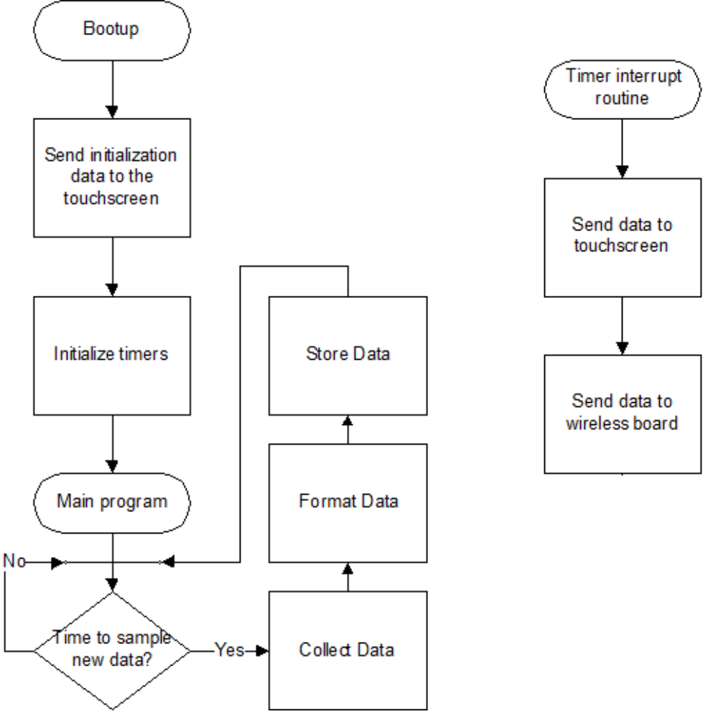

Figure 6-1: System High-level Block Diagram
Figure 6-1 shows the structure of the tasks that are required to implement the microcontroller for the WiDAS. There is a heavy dependence on timer interrupts in this system due to the time sensitive calculations that the microcontroller periodically executes. The Timer 0 interrupt routine in the SiLabs 8051F120DK creates the desired 100 [ms]data refresh rate that Excel and the touch-screen device require for this project.

The characteristics of the sensors connected to the microcontroller inputs are shown in Table 7-1. The SiLabs 8051F120DK is configured with 8 analog-to-digital converter (A/D) inputs and 1 counter available for data acquisition. Inspection of the data types provided by the sensors listed in Table 7-1 reveals that two sensors provide digital output pulses. Since the microcontroller had only one counter left available to record both pulses (Timer 4), a multiplexer (MUX) was used to select each signal for 50 [ms]. The disadvantage of this approach is that the error from counting the signals increases and the resolution decreases. This is an acceptable loss; however, since the input signals are known to be fast enough to have an adequate amount of registered counts before the 50 [ms] sample is completed.

Sensor | Data Type | Notes
Wheel Speed (MPH) | Pulses | Wheel Sensor
Engine Speed (RPM) | Pulses | Ignition Coil
Coolant Temperature | Variable Resistor | Logarithmic In Nature
Battery Voltage | Voltage | Directly From Battery
Oil Pressure | Switch | Activated When Safe Pressure Is Not Maintained
Table 7-1: SAE Racecar Sensors Characteristics

Since the absolute maximum input range at any input for the 8051F120DK microcontroller is -0.3 [V] to 3.3 [V], signal conditioning circuitry has been placed between the output of each sensor within the SAE racecar and their respective inputs to the microcontroller. Although voltage division has been implemented to provided inputs to the microcontroller that should never exceed 2.4 [V], the circuit shown in Figure 8-1 has been added to each input to ensure that 2.7 [V] is never exceeded in the event of component failure or improper connection. The 1N270 diodes clamp the A/D input voltage to about 2.7 [V], and although that level exceeds the A/D’s saturation voltage of 2.4 [V], the maximum input would be significantly less than the maximum of 3.3 voltage permissible at the microcontroller’s inputs. In addition, the protection circuitry ensures that the minimum voltage applied to the A/D input can never be lower than -0.3 [V].
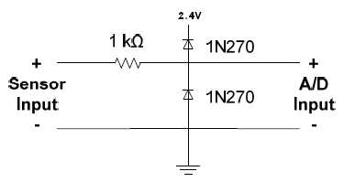
Figure 8-1: Signal Conditioning Circuitry

Data Transmission:

After processing all sensor data, the next step in implementing this WiDAS was to send the information to the Amulet touch-screen and the wireless board. Using C code, it was relatively easy to use both of the UARTs on the SiLabs 8051F120DK. However, additional hardware was required to implement the required dual communication protocol. Since only UART0 provides data output with EIA -232 voltage format, the addition of an MC1488 integrated circuit line driver was required to provide the necessary conversion from the SiLabs board’s UART1 TTL output voltage levels to the required EIA -232 voltage format. As shown in Figure 9-1, the MC1488 line driver converts the TTL output of the SiLabs board’s UART1 (top signal) to EIA -232 voltage format (bottom signal).
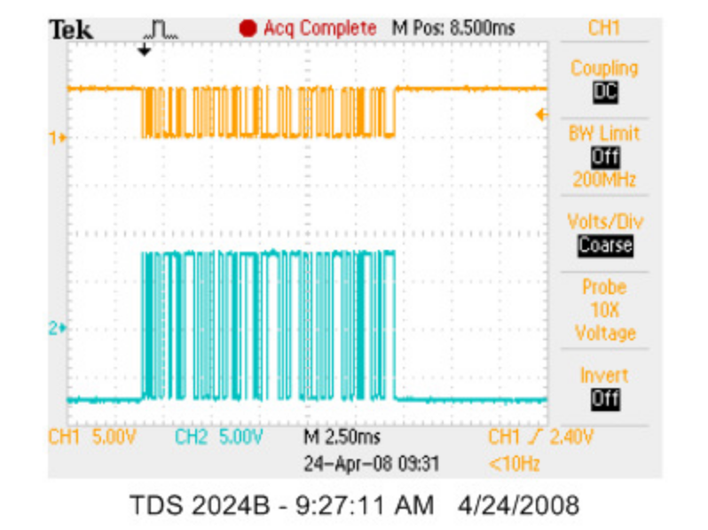
Figure 9-1: UART1’s Original Output (Channel 1) to EIA -232 (Channel 2) Conversion via MC1488 [1]

There were, however, some difficulties involved with implementing dual UARTs. Figure 10-1 shows a unique trait of SiLabs microcontroller boards. These boards have digital crossbars that complicate the task of mapping the pin-outs for the I/O of the board, which caused a considerable amount of confusion when finding the correct pins for the data acquisition aspect of this project.
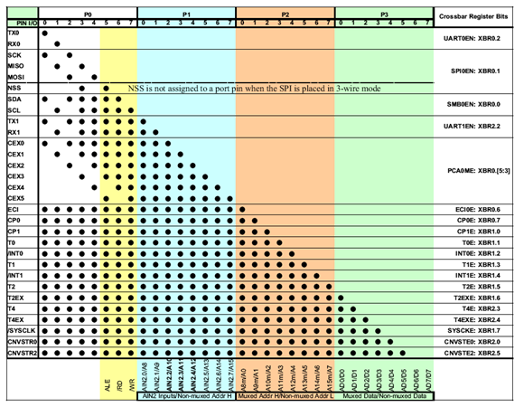
Figure 10-1: SiLabs 8051F120DK Digital Crossbar [2]

Wireless Communication:

The Chipcon CC1100 DK wireless boards create the wireless link between the SAE race car and the off-track laptop. Using the development libraries that came with these devices, it did not take long to get the wireless link completed. Sending data in a FIFO buffer of variable length, these boards act as a virtual EIA -232 cable that sends data in packets. Figure 11-1 shows a picture of one of the Chipcon devices that is being used in this WiDAS. Designed to transfer data at 250 kbps wirelessly and communicate at 115 kbps on its EIA-232 interfaces, these Chipcon devices are more than adequate for sending 200 bytes per second, or 20 bytes every 100 [ms]. Since the baud rate for the wireless transmission is well above that used by the EIA -232 interfaces, additional functionality can be added to this system, such as headset communication between the two wireless boards.
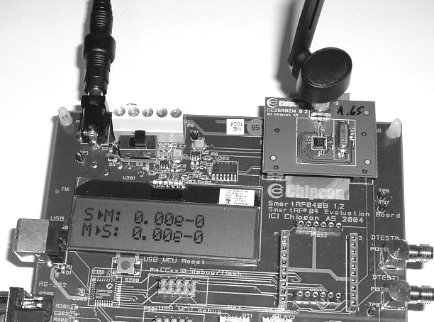
Figure 11-1: Chipcon Wireless Board

Functioning at a 433 Mhz carrier frequency, these Chipcon devices have a performance of 1% error per every 20 byte packet sent while in a 3 mile transmission range. Appendix B shows the C code implementation for these boards.

Data Destination:
The following subsections explain the development challenges of the WinWedge/Excel interface and the Amulet touch-screen.
Touch-screen Display:

The Amulet STK-480272C LCD touch-screen allows for a rich GUI that is flexible and relatively easy to augment. After discussions with the mechanical engineering SAE race car team, the display configuration shown in Figure 12-1 was developed. The mechanical engineering team indicated that since the most important gauge was for engine speed in revolutions per minute (RPM), it needed to be significantly larger than the other gauges.
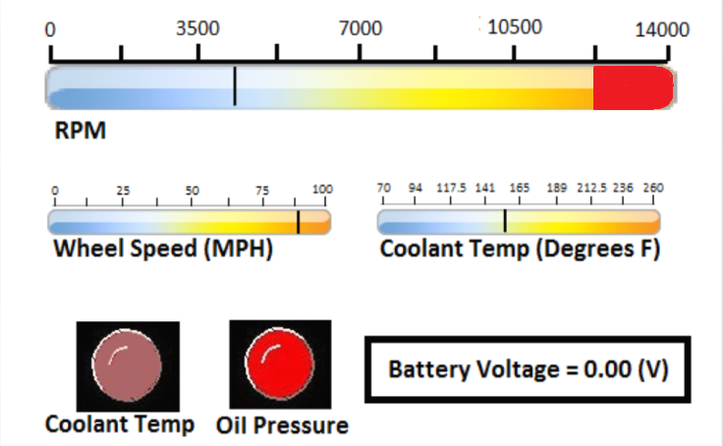
Figure 12-1: Amulet Touch-screen GUI Layout

Created in Expressions Web, the GUI for the touch-screen is straight forward in design. However, there are some quirks with the Amulet widgets: the linear gauges, digital gauges, and warning lights. The development language used to program the Amulet touch-screen devices is called µHTML, and although similar, it is not the same as HTML. Appendix A contains some of the most important differences between programming in µHTML as opposed to HTML. After knowing how to interact with the touch-screen’s internal memory system over a EIA-232 interface, the most difficult part of the design was getting the GUI to be aesthetically pleasing. This is difficult due to the positioning limitations and quirks that arise from the conversion between HTML and µHTML. Appendix A also contains information on how to communicate with the LCD touch-screen.

Touch-screen Selection:
Using Table 14-1, it is relatively easy to eliminate technologies that are not suited for a SAE racecar application. Surface capacitive technology does not allow for a gloved hand to be registered, and this effectively eliminates this technology from consideration. In addition, a durable shell with the ability to seal the device is very important, thus eliminating Surface Acoustic Wave (SAW) and resistive technologies, since SAW technology is not sealable and resistive technology has only fair durability. Finally, infrared technology is not optimal for the type of sunny environment that is typically involved with SAE race car driving. This makes a projected capacitive display the most logical choice for the implementation of the SAE race car application, since the only disadvantage for projected capacitive displays is that is has a lower resolution than the other technologies.
Table 14-1: Touch-screen Technology Comparison [3]
Feature | Infrared (IR) | Resistive (5-wire) | Surface Capacitive | Projected Capacitive | SAW
Gloved Hand | Yes | Yes | No | Yes | Yes
Seal Capable | Yes | Yes | Achieved with  Correct Material | Yes | No
Durability/Wear | Excellent | Fair | Good | Excellent | Excellent
Calibration Stability | Excellent | Fair to Excellent | Good to Excellent | Good to Excellent | Excellent
Light Transmission | 92-99% | 75-88% | 88-93% | ≤91% | 90%

WinWedge/Excel Interface:
WinWedge is a program that accepts an EIA-232 communication-port signal and processes the information for compatible entry into a specified windows program. After defining the information shown in Figure 15-1, the information from the EIA -232 interface can be directly imported to Excel in real-time.
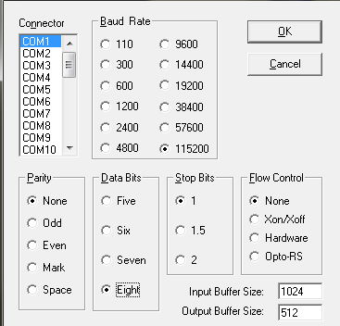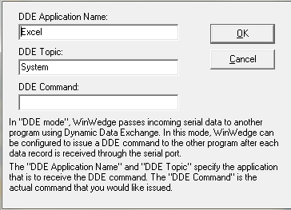
Figure 15-1: WinWedge Data Input Parameters

Importing data from WinWedge into Excel is done by connecting the “input fields” of WinWedge, shown in Figure 15-2, with the cells in Excel. Using the command “=WinWedge|'Com1'!'Field(1)'” in an Excel cell, one can specify that they want to tie the specific cell in Excel to field 1 of WinWedge’s input field, shown in Figure 15-2. This allows for real-time viewing of the information.
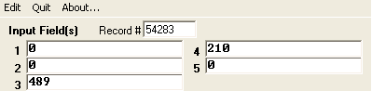
Figure 15-2: WinWedge’s Input Fields

Using a program called DataQ XControls, the interactive dashboard shown in Figure 16-1 can be implemented. DataQ ties a cell in Excel to an interactive gauge through macros. This means that whenever a value inside a cell in Excel changes, its corresponding gauge will also change, accordingly.
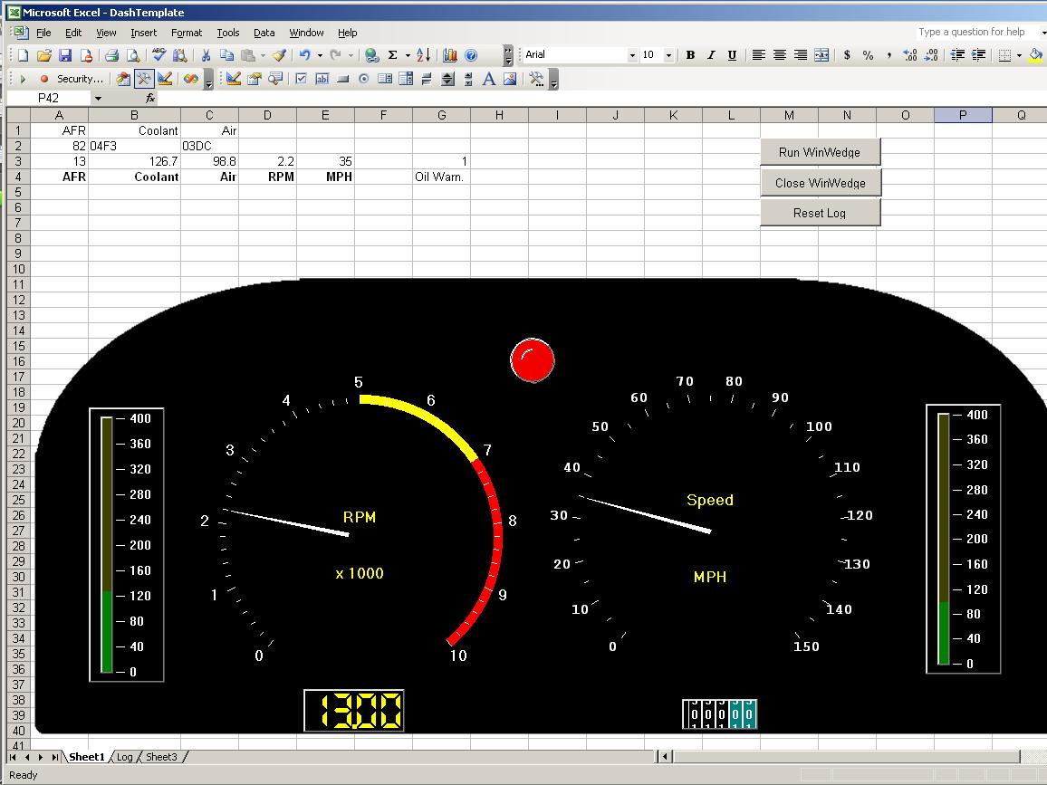
Figure 16-1: Real-Time Dashboard for an Off-Track Laptop User

PATENTS:
The information in Table 17-1 below shows the relevant patents involving wireless data acquisition systems. As all of the other components inside the system are purchased from companies, there are no infringements involving their patents if they are purchased from their respective manufacturers.

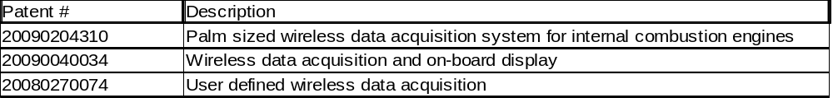
Table 17-1: Relevant Patents

EQUIPMENT:
Chipcon CC1100 DK wireless boards (2)
MC1488 – TTL to EIA-232 conversion IC
SiLabs 8051F120DK MCU
Amulet STK-480272C LCD touch-screen
WinWedge EIA -232 software interface
1N270 Germanium Diodes (2), 1k Resistor – protection circuit
EIA-232 Breakout Connectors (2) – for EIA-232 pin connections
CONLUSION:
This WiDAS is currently in a semi-finished state at the end of the 2010 spring semester. Although all of the requirements for system functionality have been met, the hardware conditioning circuitry has not been implemented due to lack of sensor availability. All other aspects of the system have been verified through testing and can be augmented quickly due to the flexibility that C code provides.

SOURCES:
[1] Pieper, Tim. “Wireless Data Acquisition System : Functional Requirements List & Performance Specifications,” May 12, 2008. [Online], Available:
http://cegt201.bradley.edu/projects/proj2008/widas/pdf/Functional%20Requirements .pdf. [Accessed: Apr. 15, 2010].

[2] SiLabs, 8051F120DK Datasheet.

[3] "Touch Display Technology,"Planarembedded.com, Dec. 12, 2009. [Online]. Available:
http://www.planarembedded.com/technology/touch/. [Accessed: Mar. 20, 2010].

Chipcom, C1100 DK Users Guide.

Amulet Technologies, STK-480272C LCD Touch-screen Users Guide.

WinWedge32, Standard User Guide.

Appendix A: Amulet Touch-screen µHTML

Communication Format
Communications between the Amulet LCD module and an external processor are asynchronous serial transmissions, with the following format:
Baud Rate: 9600, 19200, 57600, or 115200bps
Parity: None
Data Bits: 8
Stop Bits: 1
The default baud rate is 115,200 bps. Other baud rates are set by using a META tag in the <HEAD> section of the HTML page by using the Amulet META attribute, where the baud is either 9600, 19200, 57600, or 115200.
Example:
<META NAME="Amulet" Content="Baud.Project=19200">

Numeric Field Widget
<APPLET CODE="NumericField.class" WIDTH="160" HEIGHT="25" NAME="Field1">
<PARAM NAME="fillColor" VALUE="gray">
<PARAM NAME="fontColor" VALUE="black">
<PARAM NAME="fontSize" VALUE="4">
<PARAM NAME="fontStyle" VALUE="BOLD|ITALIC">
<PARAM NAME="href" VALUE="Amulet:UART.byte(3).value()">
<PARAM NAME="max" VALUE="255">
<PARAM NAME="min" VALUE="0">
<PARAM NAME="maxFld" VALUE="5.00">
<PARAM NAME="minFld" VALUE="-5.00">
<PARAM NAME="printf" VALUE="Output = %5.2f Volts">
<PARAM NAME="updateRate" VALUE=".33,0.01">
</APPLET>

Linear Gauge Widget
<APPLET CODE="LinearGauge.class" WIDTH="80" HEIGHT="170" NAME="LinGauge1">
<PARAM NAME="backgroundImage" VALUE="background.gif">
<PARAM NAME="href" VALUE="Amulet:UART.byte(15).value()">
<PARAM NAME="max" VALUE="255">
<PARAM NAME="min" VALUE="0">
<PARAM NAME="minAt" VALUE="bottom">
<PARAM NAME="pointerImage" VALUE="pointer.gif">
<PARAM NAME="updateRate" VALUE=".25,.05">
</APPLET>

Image Sequencing Widget
<APPLET CODE="ImageSeq.class" WIDTH="200" HEIGHT="110" NAME="ImageSeq1">
<PARAM NAME="href" VALUE="Amulet:UART.byte(17).value()">
<PARAM NAME="max" VALUE="5">
<PARAM NAME="min" VALUE="0">
<PARAM NAME="sequence" VALUE="seq0.gif;seq1.gif;seq2.gif;seq3.gif;seq4.gif;seq5.gif>
<PARAM NAME="updateRate" VALUE=".22,0.01">
</APPLET>

Communication Between MCU & LCD Touch-screen

Message | Byte 1 | Byte 2 | Byte 3 | Byte 4 | Byte 5 | Byte 6 | Byte 7 .......... Byte N
Amulet Get Byte Variable (from LCD) | 0xD0 | Variable  Hi Nibble | Variable  Lo Nibble | None | None | None | None | None
Server Response (from MCU) | 0xE0 | Variable  Hi Nibble | Variable  Lo Nibble | Value  Hi Nibble | Value  Lo Nibble | None | None | None
(Please note that the variable Hi and Lo are sent in ascii format. Example: 0xF2 value is sent to the touch-screen by sending the characters ‘F’ and ‘2’.)

http://www.amulettechnologies.com/GEMhelp/Help.htm

Appendix B: Wireless Board C Code
SerialLink.c
#include <Chipcon\srf04\regssrf04.h>
#include <Chipcon\srf04\halsrf04.h>
#include <Chipcon\srf04\ebsrf04.h>
#include <Chipcon\srf04\culsrf04.h>
#include <SerialLink.h>
#include <stdio.h>
#include <ctype.h>

//-------------------------------------------------------------------------------------------------------
// void halSpiWriteBurstReg(BYTE addr, BYTE *buffer, BYTE count)
//
// DESCRIPTION:
// This function writes to multiple CCxxx0 register, using SPI burst access.
//
// ARGUMENTS:
// BYTE addr
// Address of the first CCxxx0 register to be accessed.
// BYTE *buffer
// Array of bytes to be written into a corresponding range of
// CCxx00 registers, starting by the address specified in _addr_.
// BYTE count
// Number of bytes to be written to the subsequent CCxxx0 registers.
//-------------------------------------------------------------------------------------------------------

//-------------------------------------------------------------------------------------------------------
// Macros which are helpful when transmitting and receiving data over the serial interface.
//
// Example of usage:
//
// UART_TX_ENABLE();
// UART_TX(data);
//
// for (i = 1; i < len; i++) {
// UART_WAIT_AND_SEND(pData[i]);
// }
//
// UART_RX_ENABLE();
// len = UART_RX();
//
// while (len-- > 0) {
// UART_WAIT_AND_RECEIVE(data[i++]);
// }

//-------------------------------------------------------------------------------------------------------
// DESCRIPTION:
//
// By moving the joystick right and left, the user can set up one unit for TX (left) or RX (right).
// After setting the correct mode, the user must press the joystick button to start the link tester.
// The transmitter will send one packet every time the S1 button is pushed.
// Number of packets that have been transmitted is showed on the LCD display. The RX unit will display
// number of packets received with CRC OK.
// The program uses halRfSendPacketSerial() and halRfReceivePacketSerial()
//
// |---|---|---|---|---|---|---|---|---|---|---|---|---|---|---|---|
// | S | e | n | t | : | | | | | | | | | | | |
// |---|---|---|---|---|---|---|---|---|---|---|---|---|---|---|---|
// | 2 | 5 | 8 | | | | | | | | | | | | | |
// |---|---|---|---|---|---|---|---|---|---|---|---|---|---|---|---|
//
//-------------------------------------------------------------------------------------------------------

//---------------------------------------------------------------------------// Global Variables

UINT16 xdata checksum;
UINT8 xdata receivedCRC[2];

BYTE xdata txBuffer[] = {0x55, 0x55, 0x55, 0x55, // Preamble
SYNC3, SYNC2, SYNC1, SYNC0, // Sync word
15, 'b', 'c', 'd',
'e', 'f', 'g', 'h','i','j','k',
'a', 'b', 'c', 'd', // Payload of 15 BYTES
'z',
CRC1, CRC0}; // CRC (optional)

BYTE xdata rxBuffer[17]; ///////////
UINT8 xdata mode = MODE_NOT_SET;

BYTE xdata asciiString[11];
//---------------------------------------------------------------------------

//---------------------------------------------------------------------------
// void main(void)
//
// DESCRIPTION:
// This program shows how how to set up a link between two units.
//---------------------------------------------------------------------------
void main (void) {
UINT8 xdata len = 0;
UINT8 xdata joystickPosition = JOYSTICK_CENTER;
UINT8 xdata prevJoystickPosition = JOYSTICK_CENTER;
UINT32 xdata packetsReceived = 0;
UINT32 xdata packetsSent = 0;
UINT8 data i = 0;
UINT8 data j = 0;
UINT8 data dataByte = 0;

#ifdef STAND_ALONE

// Select the Internal Oscillator as Multiplier input source and disable the watchdog timer
// SYSCLK = 4X Clock Multiplier / 2
CLOCK_INIT();
#endif

// Set up the crossbar and I/O ports to communicate with the SmartRF04EB peripherals
IO_PORT_INIT();

// Initialize the LCD display. The SMBus uses timer 0 to generate SCL
ebLcdInit();

ebLcdUpdate("Select Mode", "Using Joystick");

// Initialize the ADC converter
ebAdcInit(ADC_JOY);

SPI_INIT(SCLK_6_MHZ);

POWER_UP_RESET_CCxxx0();

// 8-bit Uart with variable baudrate, logic level of stop bit is ignored. User must poll the
// RI_0 and TI_0 flag to determine when a byte arrives or when the TX buffer is empty.
// Timer1 is used as a baudrate generator
halUartSetup(UART_BAUDRATE_115200, DEFAULT_MODE);

UART_RX_ENABLE(); // enables reading from the UART

halRfWriteRfSettings(&rfSettings);
halSpiWriteReg(CCxxx0_IOCFG1, 0x0B); // Serial clock

halSpiWriteReg(CCxxx0_PATABLE, paTable);

// Select Tx or Rx mode by moving the joystick right or left
do {

halWait(250);

// Get current position of joystick
joystickPosition = ebGetJoystickPosition();

if (prevJoystickPosition != joystickPosition)
parseMenu(joystickPosition);

prevJoystickPosition = joystickPosition;

} while (!ebJoyPushed());

// Infinite loop
while (TRUE) {
switch (mode) {

case RX: // receive mode never ends until power cycle.

// Infinite loop
while (TRUE) {
if (halRfReceivePacketSerial(rxBuffer, SYNC3, SYNC2, SYNC1, SYNC0, VARIABLE_LENGTH, CRC_ENABLE)) {
intToAscii(++packetsReceived);
//rxBuffer[9] = NULL; // null for display purposes
//ebLcdUpdate("Received:", &rxBuffer[1]); // displays what was received on the LCD
printf("%c %c %c %c %c %c %c %c %c %c %c %c %c %c %c", rxBuffer[1], rxBuffer[2], rxBuffer[3], rxBuffer[4], rxBuffer[5], rxBuffer[6], rxBuffer[7], rxBuffer[8], rxBuffer[9], rxBuffer[10], rxBuffer[11], rxBuffer[12], rxBuffer[13], rxBuffer[14], rxBuffer[15]); // where i print to the computer the information obtained over the RF
}
}
break;

case TX: // transmit mode. same as receive mode.

P0MDOUT |= GDO0_; // In TX, GDO0 is serial data input, and must be configured as a push/pull output
// on the MCU
UART_RX_ENABLE();
while (TRUE) {
//int i = 0;
//while (!ebButtonPushed()); // will take out eventually, will wait for reading of serial port. keep in until tested on hyperterminal.
//len = SBUF0;
len = 8;
//LED = not LED;
//while (len-- > 0) {

UART_WAIT_AND_RECEIVE(txBuffer[9]);
UART_WAIT_AND_RECEIVE(txBuffer[10]);
UART_WAIT_AND_RECEIVE(txBuffer[11]);
UART_WAIT_AND_RECEIVE(txBuffer[12]);
UART_WAIT_AND_RECEIVE(txBuffer[13]);
UART_WAIT_AND_RECEIVE(txBuffer[14]);
UART_WAIT_AND_RECEIVE(txBuffer[15]);
UART_WAIT_AND_RECEIVE(txBuffer[16]);

UART_WAIT_AND_RECEIVE(txBuffer[17]);
UART_WAIT_AND_RECEIVE(txBuffer[18]);
UART_WAIT_AND_RECEIVE(txBuffer[19]);
UART_WAIT_AND_RECEIVE(txBuffer[20]);
UART_WAIT_AND_RECEIVE(txBuffer[21]);
UART_WAIT_AND_RECEIVE(txBuffer[22]);
UART_WAIT_AND_RECEIVE(txBuffer[23]);

//}

halRfSendPacketSerial(txBuffer, sizeof(txBuffer), START_OF_PAYLOAD, CRC_ENABLE);

intToAscii(++packetsSent);
ebLcdUpdate("Sent:", asciiString);
}
break;
}
}
}

//-------------------------------------------------------------------------------------------------------
// void intToAscii(UINT32 value)
//
// DESCRIPTION:
// Takes a 32 bits interger as input and converts it to ascii. Puts the result in the global
// variable asciiString[]
//
// ARGUMENTS:
// UINT32 value
// The value to be converted
//-------------------------------------------------------------------------------------------------------
void intToAscii(UINT32 value) {
UINT8 i;
UINT8 j = 0;
UINT8 digit_start = 0;
UINT16 digit = 0;
UINT32 denom = 1000000000;

if (value == 0) {
asciiString[0] = '0';
asciiString[1] = NULL;
} else {
for(i = 10; i > 0; i--) {
digit = value / denom;
if((digit_start == 1) || (digit != 0)) {
digit_start = 1;
value %= denom;
asciiString[j++] = (digit + '0');
}
denom /= 10;
}
asciiString[j++] = NULL;
}
}// intToAscii

//-------------------------------------------------------------------------------------------------------
// void parseMenu(UINT8 joystickPosition)
//
// DESCRIPTION:
//
//-------------------------------------------------------------------------------------------------------
void parseMenu(UINT8 joystickPosition) {

switch (joystickPosition) {

case JOYSTICK_LEFT:
if (mode == RX || mode == MODE_NOT_SET) {
mode = TX;
ebLcdUpdate("Mode: Tx", NULL);
}
break;

case JOYSTICK_RIGHT:
if (mode == TX || mode == MODE_NOT_SET) {
mode = RX;
ebLcdUpdate("Mode: Rx", NULL);
}
break;

default:
break;
}
}// parseMenu
Appendix C: Microcontroller C Code
Main.c
// Program Additions Copyright (C) 2010 Justin Peters
//
// Date: 2010
// Target: C8051F12x
//
//
// It runs on a C8051F120DK board.
//
///////////////////////////////////////////////////////////////
// Main.c description
// This module is the main C file in this project for the WiDAS
///////////////////////////////////////////////////////////////

#include "C8051F120.h" // Device-specific SFR Definitions
#include "C8051F120_io.h" // Device-specific SFR Definitions

#include "am_init.h" // configuration settings for a lot of the functionality of the board.
#include "am_com.h" // UART config as well as the communication protocol code.
#include "uartISR.h" // not used currently.
#include "adc0int8.h" // for ADC0 functionality.
#include "timer4counter.h" // digital pulse functionality settings.

#include <stdio.h> // used for printing strings

#define BAUDRATE 115200 // Baud rate of UART1 in bps
// Baud rate of UART0 in bps is hardcoded in
// timer2 setup in UART_Init() but is 115200

#define SAMPLE_RATE (50000L) // Sample frequency in Hz of the AD0

#define StatusPlease 3 // these three are for UARTgotten function. these are unimplimented
#define NotGotten 0 // the interrupt routines for the UART do not do anything as of now
#define Gotten 1 // future development can be done to make the UART do bi-direction communication

unsigned long count100ms = 0; // variable used to count in the interrupt handler Timer0ISR for .05 sec critical timing (inside main.c)
char uartgotten = 0;
__xdata char buf_test[20]; // storage for message received.
char currentlyreading = 0; // character to specify currently reading a UART
char readytoprint = 0; // set to different values in the timer for the .05 second timing
char buf4amulet[6]; // buffer before sending out on UART1 to the touchscreen
int conversion4amulet = 0; // a variable for ascii conversion (used right after it is set)

void main(void)
{

// Disable watchdog timer
WDTCN = 0xde;
WDTCN = 0xad;

// Initialize the MCU
PORT_Init();
SYSCLK_Init();
UART_Init(SYSCLK, BAUDRATE); // uses timer 1 and 2 (dont use those timers for anything else)
ADC0_Timer3_Init(SYSCLK, SAMPLE_RATE); // timer 3 is being used for the ADC
Timer0interrupt(); // defined in bottom of am_com.c

EA = 1; // Enable global interrupts

SetupCounter(); // setup timer4 for counting pulses for digital pulse reader from an external pin

LED = 0;

/////////////////////////////////////////////////////////
////// MAIN LOOP BELOW///////////////////////////////////
/////////////////////////////////////////////////////////
// This loop does the following:
// 1.) waits for timer 0 to set "readytoprint = 1"
// in timer 0's .05 critical timing (if starting
// with value of "readytoprint = 0".
// Once set, it ends the counting for the pulses
// counting from the RPM digital pulses and then
// sets counting for MPH (50% counting RPM pulses
// or .05 seconds and 50% for MPH). readytoprint
// is then set to a transitional '3' value.
// 2.) After another .05 seconds, (if readytoprint ==3)
// readytoprint is set to 2. This allows for the
// printing of MPH as well as the ADC values.
/////////////////////////////////////////////////////////
/////////////////////////////////////////////////////////

while (1)
{
__xdata char buffer[16]; // character buffer for output.
int pulses = 0;
int ch; // A/D channel picking ( 0 to 7)

////////////////////////////////////////////////
////// Section for RPM//////////////////////////
////////////////////////////////////////////////
if(readytoprint == 1){ // readytoprint == 1 says that we should be muxing the counting mechanism to get MPH first and then RPM (RPM is recieved in readytoprint == 2).

UART_put("A",0);
// something to do with muxing.
// do muxing here... not yet implemented...

//...

SFRPAGE = TMR4_PAGE;

TMR4CN = 0x02; // disables counting for now
// read count
pulses = 0;
pulses = TMR4H << 8; // shift left 8 times (high byte needs to be shifted to be true value)
pulses = pulses + TMR4L;

sprintf(buffer, "%5d", pulses); // this was counted during LED = 0 duration.
UART_put(buffer,0); // sending values over to the wireless board. (5 digits)

TMR4H = 0;// clear count
TMR4L = 0;// clear count
TMR4CN = 0x06; // enables counting

SFRPAGE = TIMER01_PAGE;

/// below is for amulet touchscreen.
pulses = pulses / 90; // converts to 0 thru 0xFF with a 14000 RPM max
conversion4amulet = pulses >> 8; // high byte of pulses
pulses = pulses && 0xFF; // lower byte of original pulses.

buf4amulet[0] = 0xE0;
buf4amulet[1] = '0';
buf4amulet[2] = '1'; // [1] and [2] are for RPM widget. It is widget 0x01.

if(conversion4amulet > 9) conversion4amulet = conversion4amulet + 55; // converted to ascii
else conversion4amulet = conversion4amulet + 48;

if(pulses > 9) pulses = pulses + 55;
else pulses = pulses + 48;

buf4amulet[3] = conversion4amulet;
buf4amulet[4] = pulses;
buf4amulet[5] = 0;

//&&&&&&&&&&&&&&&&&&&&&&&&&&&&&&UART_put(buf4amulet,1);
// done with amulet touchscreen section

readytoprint = 3; // transitional value that is set to 2 in the .05 second critical timing.

}

////////////////////////////////////////////////
//////END of section for RPM////////////////////
////////////////////////////////////////////////

if(readytoprint == 2){

/////////////////////////////////////////
// portion for counting ..........MPH////
/////////////////////////////////////////

SFRPAGE = TMR4_PAGE;

TMR4CN = 0x02; // disables counting for now
// read count
pulses = 0;
pulses = TMR4H << 8; // shift left 8 times (high byte needs to be shifted to be true value)
pulses = pulses + TMR4L;

sprintf(buffer, "%3d", pulses); // counted during LED = 1 duration.
UART_put(buffer,0);
//UART_put("\n",0);

TMR4H = 0;// clear count
TMR4L = 0;// clear count
TMR4CN = 0x06; // enables counting

SFRPAGE = TIMER01_PAGE;

/// below is for amulet touchscreen.
pulses = pulses / 90; // converts to 0 thru 0xFF with a 14000 RPM max
conversion4amulet = pulses >> 8; // high byte of pulses
pulses = pulses && 0xFF; // lower byte of original pulses.

buf4amulet[0] = 0xE0;
buf4amulet[1] = '0';
buf4amulet[2] = '2'; // [1] and [2] are for MPH widget. It is widget 0x01.

if(conversion4amulet > 9) conversion4amulet = conversion4amulet + 55; // converted to ascii
else conversion4amulet = conversion4amulet + 48;

if(pulses > 9) pulses = pulses + 55;
else pulses = pulses + 48;

buf4amulet[3] = 'F';
buf4amulet[4] = 'F';
buf4amulet[5] = 0;

//&&&&&&&&&&&&&&&&&&&&&&&&&&&&&&&UART_put(buf4amulet,1);
// done with amulet touchscreen section

////////////////////////////////////////
// END of portion for counting MPH//////
////////////////////////////////////////

for(ch=0; ch<2; ch++) // for ADC channel 0 and 1
{
// Read the latest A/D results
unsigned int value = getRecentResult(ch);

int converted = (long)value * VREF / ADC0_MAX;

if (ch == 1) converted = converted / 3;
if (converted > 999) converted = 999;

sprintf(buffer,"%3d",converted);

UART_put(buffer,0);

// demo purposes below....%%%%%%%
if (ch == 0){
converted = converted / 4; // range roughly 0 - 999 / 4 or 0 - ~0xFF (249) range

conversion4amulet = converted >> 4; // high nibble of converted
converted = converted && 0x0F; // low nibble of original converted value.

buf4amulet[0] = 0xE0;
buf4amulet[1] = '0';
buf4amulet[2] = '1'; // [1] and [2] are for MPH widget. It is widget 0x01.

if(conversion4amulet > 9) conversion4amulet = conversion4amulet + 55; // converted to ascii
else conversion4amulet = conversion4amulet + 48;

if(converted > 9) converted = converted + 55;
else converted = converted + 48;

buf4amulet[3] = conversion4amulet;
buf4amulet[4] = converted;
buf4amulet[5] = 0;

UART_put(buf4amulet,1);
}
// end of demo purpose... %%%%%%
}

ch = 2; // for ADC channel 2 below.
// this is for the oil pressure warning.
{

unsigned int value = getRecentResult(ch);

int converted = (long)value * VREF / ADC0_MAX;
converted = converted / 100;

if (converted > 9) converted = 9;
sprintf(buffer,"%1d",converted);

UART_put(buffer,0);

// the below amulet code is for demonstration purposes for the touchscreen's warning light.
buf4amulet[0] = 0xE0;
buf4amulet[1] = '0';
buf4amulet[2] = '5'; // [1] and [2] are for RPM widget. It is widget 0x01.
buf4amulet[3] = '0';
if (converted > 1) converted = 1;
buf4amulet[4] = converted + 48;
buf4amulet[5] = 0;

UART_put(buf4amulet,1);

}

UART_put("B",0); // the end of the packet for the wireless board.
readytoprint = 0; // restart sequence, packet for wireless is done.

//buf4amulet[0] = 0xE0; // the write command
//buf4amulet[1] = '0';
//buf4amulet[2] = '1'; // [1] and [2] specify which widget. It is widget 0x01.
//buf4amulet[3] = 'C';
//buf4amulet[4] = 'C'; // [3] and [4] specify which value to set the widget to (0xCC)
//buf4amulet[5] = 0; // null for the UART function.

//UART_put(buf4amulet,1);

buf4amulet[0] = 0xE0;
buf4amulet[1] = '0';
buf4amulet[2] = '2';
buf4amulet[3] = 'A';
buf4amulet[4] = 'C';
buf4amulet[5] = 0;

UART_put(buf4amulet,1);

buf4amulet[0] = 0xE0;
buf4amulet[1] = '0';
buf4amulet[2] = '3';
buf4amulet[3] = '7';
buf4amulet[4] = 'C';
buf4amulet[5] = 0;

UART_put(buf4amulet,1);

buf4amulet[0] = 0xE0;
buf4amulet[1] = '0';
buf4amulet[2] = '4';
buf4amulet[3] = '0';
buf4amulet[4] = '0';
buf4amulet[5] = 0;

UART_put(buf4amulet,1);

buf4amulet[0] = 0xE0;
buf4amulet[1] = '0';
buf4amulet[2] = '6';
buf4amulet[3] = 'F';
buf4amulet[4] = 'F';
buf4amulet[5] = 0;

UART_put(buf4amulet,1);

}

}

}

void Timer0_ISR (void) __interrupt 1 // for .05 second critical timing creation.
{

if (count100ms >= 38281/2) { // happens every .05 seconds (50ms) due to muxing the counter. half the time is on MPH and the other is RPM.

if (readytoprint == 0){
readytoprint = 1; //inside main function can print all of the data to both wireless and touchscreen.

LED = 1; // mux
}

else{

readytoprint = 2;
LED = 0; //mux
}

count100ms = 0;
}

else {
count100ms++;
}

}

