Senior Capstone Project Formal Report
Reconfigurable FPGA Implementation
Of Digital Communication System

Project Members
Steve Koziol
Josh Romans

Project Advisor
Dr T.L. Stewart

Bradley University
Department of Electrical & Computer Engineering
EE 452 – Senior Laboratory
May 4, 2006

Table of Contents

Table of Images…………………………………………………………………… 2
Abstract……………………………………………………………………………. 3
Introduction……………………………………………………………………….. 4
Functional Description…………………………………………………………… 4
System Block Diagram …………………………………………………………… 5-6
Receiver……………………………………………………………………………. 7
Multiplier…………………………………………………………………………... 8-10
FIR Filter…………………………………………………………………………... 11
Conclusion…………………………………………………………………………. 11
Equipment List……………………………………...…………………………….. 12
References……………………………………………………………………….… 12
Appendix 1 – Reference Abstracts………………………………….…………….. 12

Table of Images

Figure 1: RFIDCS High level view……………………………………………… … 4
Figure 2: Expanded System View……………………………………………… … 5
Figure 3: FPGA Data Flow…………………………………………………………. 6
Figure 4: Receiver Module…………………………………………………………. 7
Figure 5: Booth Multiplication Flowchart…………………………………………. 8
Figure 6: Booth Multiplication Partial Schematic 1……………………………….… 9
Figure 7: Booth Multiplication Partial Schematic 2……………………………….… 9
Figure 8: Quarter Period Sine Wave……………………………………………….… 10
Figure 9: FIR Filter Module…………………………………………………………. 11

Abstract

The objective of this project is to create a communication system in VHDL to be implemented on a single Field Programmable Gate Array (FPGA). The communication system is capable of switching between transmitter and receiver configurations without reprogramming the FPGA. An introduction to FPGA’s growing importance in the communications industry is provided along with FPGA-specific design issues including: timing, reconfigurability, space constraints, and efficient internal signal routing. The conclusion offers alternative design methods, and suggestions for further development.

Introduction
Improvements in the performance and density of FPGAs over the past decade have caused hardware and firmware designers to reexamine the role of FPGAs in their end products. The use of reconfigurable logic in FPGAs has garnered a steadily growing niche in the communications industry, particularly in newer cellular phone designs. Reconfigurable logic design involves manipulation of the logic within the FPGA at run-time. This allows the hardware to change in response to the demands placed upon the system while it is running. Benefits of using a FPGA hardware design over more traditional application specific integrated circuits (ASIC) include greater functionality with a simpler hardware design, lower system cost, and reduced time-to-market. Benefits of using a reconfigurable FPGA in a communication system include reducing the size of the product by including the transmitter and receiver on a single chip, which in turn reduces cost. [1]

Objectives
The objective of this project is to develop a digital communication system on a FPGA. The communication system will be written entirely in the VHSIC Hardware Description Language (VHDL) using the Altera Quartus II design environment for debugging, simulation, and system verification. The communication system’s transmitter and receiver will be contained on a single FPGA, making it a reconfigurable system. An amplitude modulation (AM) scheme will first be investigated, with a frequency modulation (FM) scheme to follow. The communication system will be programmed onto an Altera UP2 development board containing a FLEX EPF10K70RC240-4 FPGA.

Functional Description and System Block Diagram

Description of Inputs and Outputs
The input to the system can theoretically be any analogue signal such as voice, audio or a simple sine wave. The output of the system will be a modulated version of the input signal. The type of modulation will be dependant on the modulation scheme programmed onto the FPGA at the time (i.e. AM, FM or other). Ideally, the system will switch functionality in run-time, so that the receiver and transmitter (as shown in figure 2) will occupy minimum hardware space. Initially, a sine wave from a function generator in lab will be used as the system input for testing. Figure one shows the aforementioned input and output signals relative to the overall system flow.

Overall System Flow Diagram

Figure 1 Overall system view highlighting the input and output

Description of Input and Output Connections among Subsystems
The essential subsystem modules and their connections are indicated in figure 2 below. After undergoing an A/D conversion on an external LM ADC080X 8-bit A/D Converter, the now digitized input signal will be read by the FPGA through the receiver module. After being stored in the signal storage memory module, the input signal is then modulated, filtered, and deconstructed by the multiplier module. The filtering process (implemented through a FIR filter as shown in figure 4). The signal is then output by the FPGA configured as a transmitter to the D/A converter. The output of the D/A converter is the overall system output; a deconstructed equivalent of the input signal. The flow and timing of the data throughout the entire process is sequenced by the control logic unit module, which interacts with all the subsystems contained on the FPGA to insure that proper timing and functional constraints are met.

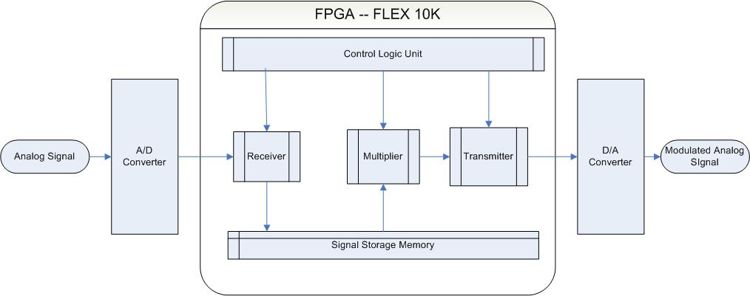

Figure 2 Expanded system block diagram

FPGA
Figure 3 highlights the flow of data within the FPGA. In addition to regulating the data flow within the FPGA, the control logic module will be instrumental in switching the FPGA between its receiver and transmitter modes. The control logic unit will also be particularly instrumental during the modulation process within the multiplication module because of the rather esoteric nature of the multiplication algorithm employed. A dedicated control sequencer within the multiplier will be developed to insure proper propagation of signal data during the modulation process.

In receiver mode, the FPGA will read and store the input data from the A/D converter. The input data will then be multiplied by an internally generated carrier frequency signal. The ideal method for producing the carrier frequency signal within the FPGA is via a sine wave generated internally. Following the multiplication, the control logic unit then switches the FPGA to transmitter mode, based on a signal generated signifying the end of the current multiplication process. The modulated product signal is then transmitted out of the FPGA to the external D/A converter.

FPGA Data Flow

Data from
A
/
D
Signal
received
and stored
Signal multiplied by internally
generated carrier frequency
signal via Booth’s algorithm
(expanded in Figure 3-1)
Product
signal stored
Mode
switching and
Control Logic
Signal sent though
transmitter
Output data
to D
/
A
FPGA in Receiver
Configuration
FPGA in Transmitter
Configuration

Figure 3 Highlighting the data flow and necessary code blocks internal to the FPGA

Each of the individual modules within the FPGA is explained and illustrated where appropriate below.

Receiver Configuration

The main purpose of the receiver module (as shown in figure 4) is to sequentially receive and store the input data signal from the A/D converter. Data reception and storage is accomplished through a series of eight eight-bit wide register banks consisting of cascaded D-Flip Flops. Data is read into this register bank at a rate of 100 KHz. The signal ‘CSL’ shown in figure 4 is produced by the control logic unit module and effectively acts as a ‘write’ signal to the register, indicating when the next valid byte of data is available and should be stored.

In order to reduce the amount of redundant code in this subsystem, once one eight bit wide register bank was successfully tested, it was instantiated as a generic component and used seven more times to complete the register bank. Instantiation involves creating an ‘instance’ of a generic unit (one register) by replacing its formal parameters by a set of matching actual parameters.

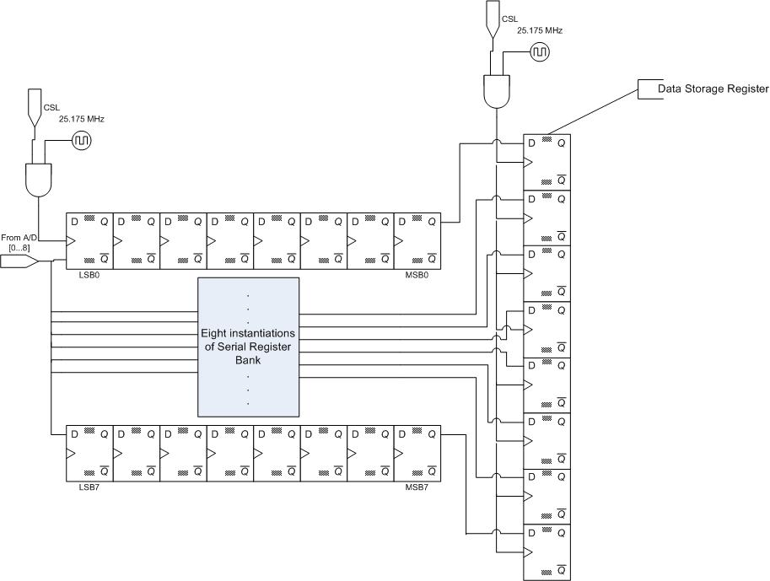
Figure 4 The receiver module

Multiplication

Figure 5 expands upon the Booth algorithm multiplication block show in figure 2. The Booth algorithm is a fast and efficient method of two signed two’s compliment variables. It is faster than conventional multiplication algorithms because it utilizes the fact that in multiplication, not all bits of the partial product need to be propagated to the next stage of summation. By eliminating the unnecessary bits, the size of the partial products generated is reduced significantly, allowing the next summation to be reached sooner and saving valuable hardware space. A partial schematic of a parallel two’s compliment Booth multiplication is shown in figure 6. Variable ‘a’ is the multiplier and ‘b’ is the multiplicand. Both are 32-bit two’s compliment numbers. The add32csa block performs the addition of the variables ‘a’ and ‘b’ and a partial schematic of this block is shown in figure 7. ‘a’ and ‘b’ are summed by the fadd block and then transmitted to the next cascaded add32csa segment.

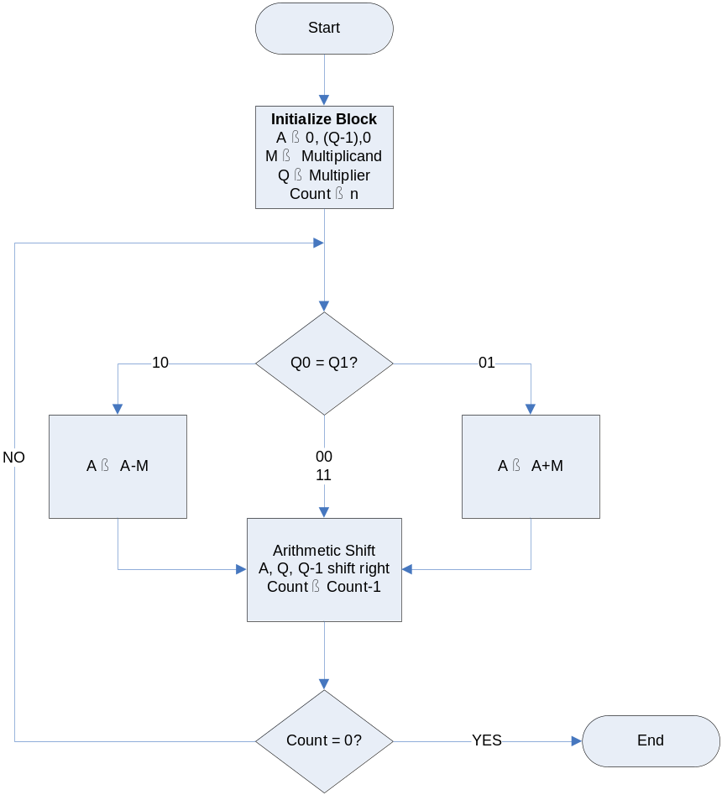
Figure 5 Data flow of the Booth multiplication algorithm

Booth Multiplication Schematics

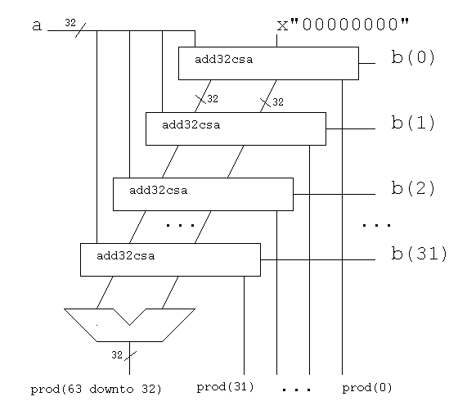
Figure 6 Booth multiplication partial schematic

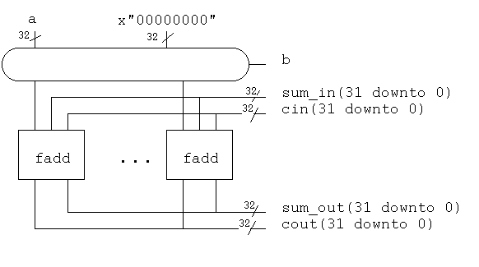
Figure 7 Partial schematic of the add32csa block in shown in figure 4-1

Multiplication (con’t)

As mentioned previously, the stored input signal is to be multiplied by a sine wave generated internally within the FPGA. The process of approximating a sine wave in VHDL was accomplished using a look-up table approach. A set of sine wave values for a quarter period (shown in figure 8) were stored within a ROM block provided in the Quartus II development environment. The quarter period was repeated four times in the following pattern: f(x), f(-x), -f(x), and -f(-x) to achieve one full sine wave period. By not storing a full sine wave period, the amount of memory required for the multiplication block was reduced by 75%.

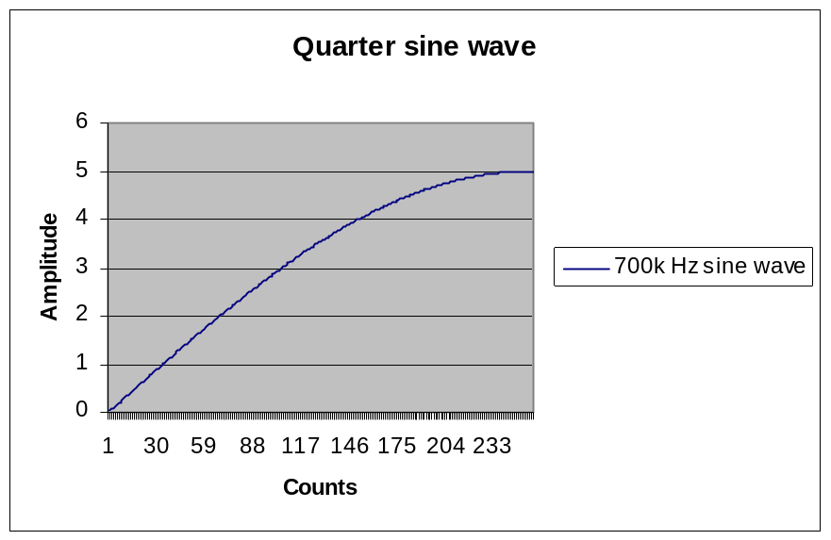

Figure 8 Example of quarter sine wave for multiplication

FIR Filter

A finite impulse response (FIR) filter (shown in figure 8) was implemented following the multiplication module. An inappropriate acquisition of noise is inherent in any signal sampling and modulation process. The purpose of this filer is to reduce the effects of the acquired high-frequency noise. An FIR filter works by multiplying an array of the most recent data samples (X) by an array of coefficients (H), and summing the elements of the resulting array. The filter then inputs another sample of data causing the oldest piece of data to be thrown away and repeats the process. The following equation illustrates the multiplication and summation process:

y(n)=h0*x(n) + h1*x(n-1) + h2*x(n-2) +…+ h13*x(n-13)

where H0-H13 are the stored filter coefficients, X is the input signal to be filtered, and Y is the filtered output signal.

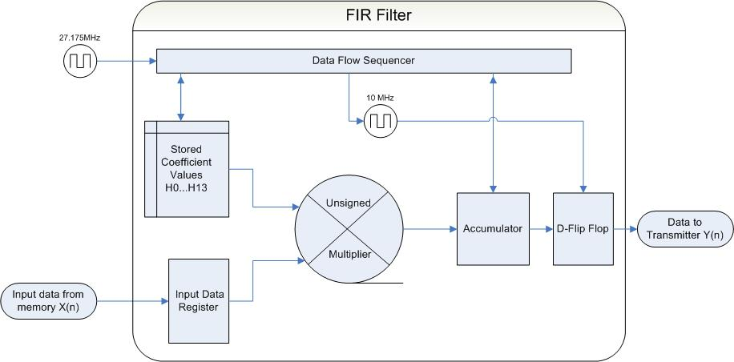

Figure 9 FIR smoothing filer diagram

Conclusion

After successfully implementing an amplitude modulation scheme on the Altera Flex 10K FPGA, sufficient space remains to attempt other modulation schemes. FM, QAM, PSK and FSK signal multiplication appear to be the next logical series of modulation schemes to attempt for future projects.

Equipment List

- Altera UP2 Development Board using FLEX10K: EPF10K70RC240-4 FPGA
- Quartus II v5.1 Web Edition Design Environment
- LM ADC080X 8-bit A/D Converter
- LM DAC080X 8-bit D/A Converter

References

[1] A Single-Chip Supervised Partial Self-Reconfigurable Architecture for Software Defined Radio – IEEE Computer Society http://csdl2.computer.org/persagen/DLAbsToc.jsp? resourcePath=/dl/proceedings/ipdps/& toc=comp/proceedings/ipdps/2003/1926/00/1926toc.xml& DOI=10.1109/IPDPS.2003.1213354

[2] University of Maryland, Department of Computer Science and Electrical Engineering, http://www.csee.umbc.edu/help/VHDL/samples/samples.shtml#mul32

[3] Khurram Muhammad, Robert Bogdan Staszewski, and Dirk Leipold, Texas Instruments, Digital RF Processing: Toward Low-Cost Reconfigurable Radios (IEEE Communication Magazine, August 2005.

Appendix 1 – Reference Abstracts

- Digital RF Processing: Toward Low-Cost Reconfigurable Radios

RF circuits for multi-gigahertz frequencies have recently migrated to state-of-the-art low cost digital CMOS processes. This article visits fundamental techniques recently developed that migrate RF and analog design complexity to the digital domain for a wireless RF transceiver. All digital phase locked loop and direct RF sampling techniques allow great flexibility in reconfigurable radio design. Digital signal processing concepts are used to help relieve analog design complexity, allowing one to reduce cost and power consumption in a reconfigurable design environment. Software layers are defined to enable these architectures to develop an efficient software-defined radio. The ideas presented have been used to develop two generations of commercial digital RF processors: a single-chip Bluetooth radio and a single-chip GSM radio.

